

**Cloud Computing for Business :**

**Project Final Report**

**Migrating e-commerce web application to cloud**



**Project Submitted to:**

**Prof. M. P. Sebastian**

**Department of Information Technology and Systems**

**IIMK**

**Submitted by Group 1:**

|  |  |
| --- | --- |
| **Name** | **Roll Number** |
| Anirban Roy Choudhury | EEPITM-01-001 |
| Satyajit Mohanty | EEPITM-01-020 |
| Gaurav Pratap Singh | EEPITM-01-004 |
| Anil C Menon | EEPGP-04C-011 |
| Siddharth Verma | EEPITM-01-023 |



Contents

Abstract 3

Introduction 3

Understanding current application and underlying architecture 4

Web application overview 4

Underlying technical architecture 5

Why Migrate? 7

Evaluating cloud computing architecture Deployment model - Private or public cloud? 8

Service model - IaaS, PaaS or SaaS? 8

Geographic Access 10

Windows Azure or Amazon Web Services? 10

Azure web role & SQL summary:- 12

Amazon Elastic Beanstalk & RDS Summary:- 12

Migration Strategy 13

Key migration issues 16

Migration risks and mitigation 18

Total cost ownership analysis 19

Future benefits 21

Conclusion 23

References 24

Disclaimer 25

# Abstract

Cloud Computing as a new internet based IT technology has attracted many of the IT enterprises in the e-commerce domain. Cloud Computing brings many benefits like saving money and resources as well as the time which is generally spend by the organization in maintaining its IT resources across the globe. It is a recent big talk among the industries and the technology entrepreneurs and paves a way for the e-commerce companies to migrate on Cloud Computing. It’s easy for the e-commerce companies to keep the customer related information secure as cloud provides better mechanisms by providing a safer way to store the information. Though there are many benefits offered by Cloud Computing, there are still many issues that should be watched seriously before moving to it. These issues involve the uniformity for cloud standards around the globe and the legal issues pertaining to different geographies and governments. The other aspect is the clod outage and no guaranteed quality of services and the associated migration efforts involved. It is also obvious for the old organizations to face the problems of new competitors as cloud may provide opportunities to the small entrants to enter in to the market with a small investment in the e-commerce domain and services. Cloud has come up as a medium to address the problems of shortage of funds, resources, manpower and technology which may be needed as an expansion of the scope and services of an organization during the expansion of its e-commerce business.

This paper puts a light on different aspects and the benefits of migration of the e-commerce industry towards the cloud computing. It also provides an overview of the e-commerce application model based on the cloud computing and discusses on the problems associated to the e-commerce.

# Introduction

Cloud computing is one of the technological area which has emerged very quickly from the theory to the real application practices in past couple of years after it was initially propose by Google Inc in the year of 2006-2007. Today many of the businesses and institutions are trying to migrate towards the cloud based solutions because of its low cost, availability dynamicity, storage capacity, network enhancing capabilities and information sharing and availability capabilities. Cloud provides the capabilities for small organizations to grow big as it can be opted as a “pay-as-usage-service” with a little initial investment needed to manage the IT infrastructure and services for any of the small or big organization. There are various service modes like IaaS (Infrastructure as a Service), PaaS (Platform as a Service) and SaaS (Software as a Service). As a revolutionary technology it is being adapted by many of the industries such as the E-Commerce, which is inevitably influenced by the countless features of cloud computing. Twitter and Facebook are very good examples of cloud technology in execution and public space. Growth of these site also shows that how the cloud computing can leverage an organization to achieve its phenomenal growth.

The development of internet and E-Commerce puts more challenges and competitions among the enterprises in terms of deciding there marketing and business strategies. It opens up new horizons by providing a large reachability to the customers by making all the geographical regions accessible for the business expansion. It brings a huge profit to the organizations though its implementation is quite expensive in terms of budget, time and resources. The evolution of cloud computing technologies gives a new opportunity to e-commerce companies’ in-terms of spending for the material resources, financial resources and manpower needed to setup the e-business system and its maintenance. This all can be handled by the cloud service providers offloading many of the responsibilities from the organizations directly to them. Instead of paying more attention towards the infrastructure and its maintenance; an organization can spent more time on improving its marketing and business strategies and improving the loyalty of its customers.

# Understanding current application and underlying architecture

## Web application overview

The current application considered for migration to cloud is a responsive, engaging and secure e-commerce web application which enables online sales of security products for direct users and user traffic via affiliate channels. This web application records significant amount of online bookings (valuation in USD) in every second with millions of active paid and active trial subscribers. This is a unified Multi-Locale (US to Arabic cultures) web site with online sales in 43 countries. This website also runs a security advice center which advices on emerging security threats and how to protect from these threats. This web application processes huge number of transactions per day, it has payment option in 59 currencies, supports for 20 Payment Types and integrates to 11 Payment Gateways.

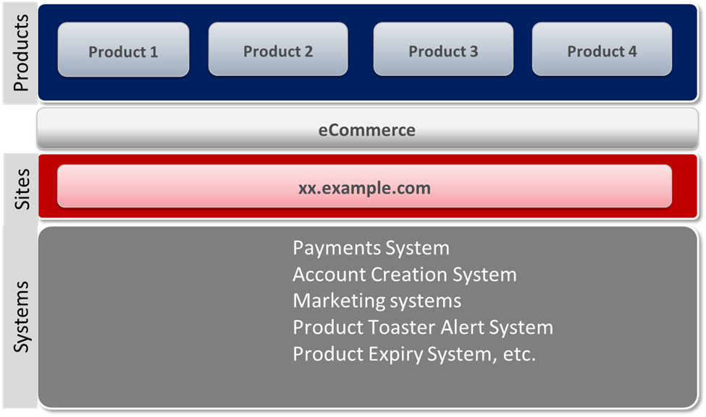

**At high level this web application does the following.**

1. Customized look & feel for partners, users etc.
2. End-users are uniquely identified
3. Provides customer support
4. Takes transactions
5. Offers customized services as per partner/affiliate agreement (SLA)
6. Customize price plan for partner/affiliates
7. Offers Co-Branded products for partners, Partner products can be sold
8. Shares revenue with partner/affiliates

## Underlying technical architecture

This e-commerce application is an ASP.NET web application which uses Microsoft technology stack such as Windows Server 2008, IIS7.5, ASP.NET4.0 and MSMQ with SQL server 2008 as back end. This website deploys an n-tier architecture which separates UI Layer (Front End), Business Layer & Database Layer for each tier such as Web & API. API tier does not involve user interface as it serves calls from Web Tier. Underlying architecture exhibit shown below.

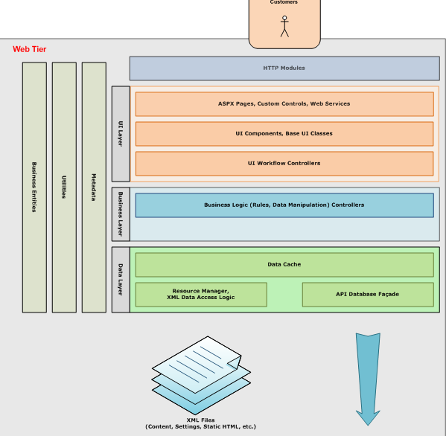



Presently this in house ASP.NET e-commerce web application runs in production with fifty windows servers (2008) in load balancer mode serving pages to the incoming traffic.

# Why Migrate?

Instead of moving towards the adaptation of cloud computing for your organization blindfolded, it’s advised to look and evaluate the benefits of moving towards it. The main point here could be to identify the basic value proposition which cloud computing adds to an organization. It may vary from one organization to another. There are mainly seven essential points because of which one should adapt the cloud based solutions for E-Commerce. These are as follows:

* Cloud computing provides the resource pooling. Physical and virtual resources can be pooled according to their consumption needs.
* Various networks, resources and data could be available easily for different geographic locations.
* It is less expensive because of its sharable nature. It also provides benefits of on-demand-service and less overhead on an organization. The organizations can deliver same tasks with a few machines in its premises. Which needs a very minimal in-house administration support.
* It provides a way to On-demand self-Service and a consumer can use it as per its needs without any human or resource interaction with any of the cloud service providers.
* It provides ability to scale the resources both in upwards and downwards as per the needs.
* Pay as per the usage philosophy.
* It paves the way for green computing as the resources can be shared and the energy requirements by them will be less. One can faster acquire and release the needed resources with the help of cloud services.

# Evaluating cloud computing architecture **Deployment model - Private or public cloud?**

This e-commerce application needs to be put up in a **Public cloud** as building a **private cloud** would involve significant amount of time and money. Today, Public Cloud providers can offer advanced enterprise-grade capabilities for security and performance, combined with network services such as load balancing and WAN optimization services. Following parameters needs to be considered when migrating to public cloud.

**WAN Traffic: -** This e-commerce application is traffic intensive but it does not communicate much with external datacenter, resources or applications. So, this application will not consume much WAN bandwidth cost and public cloud performance should be optimal.

**Data Security and Management: -** This application does not have dependency on shared datacenters storage or resources such as directory services for user, profile and data management. Therefore, migrating to public cloud with respect this point does not impose any difficulties.

**Legacy application integration:** - This application is not tied to any Legacy business applications running on platforms such as a mainframe and AS400 that might be tightly integrated and hence the risks for migration to public cloud are none with respect to this aspect.

**Security and compliance needs:-** Application security is taken care within the application and different country compliance needs are also addressed within the application along with privacy policies, opt out mechanisms and notices displayed in front end for various user flows.

## Service model - IaaS, PaaS or SaaS?

For this application we will mainly concentrate on Iaas or Paas as we need to maintain control over the application developments, enhancements and maintenance. Following parameters will be considered for Iaas or Paas model.

**SLAs: -** A PaaS vendor should provide SLAs for application platform availability and performance and incase of IaaS vendor SLA should be on the availability & performance of the server, network, storage infrastructure etc. The cloud service provider should also provide clear policies and guidelines for maintenance and version management of the platform and policies for version compatibility for APIs between the platform and the application. SLA should also mention how the potential downtime is handled.

**Data portability: -** In a PaaS or IaaS model, the application data is typically stored in a database provided by the cloud service provider. The customer must be able to export data in a format that can be migrated to other databases.

**Long-term costs:** - The financial model for a PaaS should be compared against those of an internal deployment of the infrastructure and the application server/platform using IaaS and deploying the application server using the cloud-based servers. The cost of an IaaS application should be compared against the cost of deploying that application on enterprise servers. This may provide benefits for dynamic scaling and usage based pricing involved.

**User management:** - A PaaS application will require administrative and application user accounts. For both account types, customers should understand how the user management aligns with their existing directory services and user management processes. In an IaaS model, there might be up to three different user roles: Server administrator, Application administrator & Application user. The user management procedures and tools for each of these roles should be evaluated.

**Security: -** In a PaaS deployment, the same application server might host applications from different customers. In such an environment, additional security is necessary to make sure that rogue applications are not able to exploit vulnerabilities in the platform software to affect other applications. When evaluating PaaS, enterprises should also consider platform management and scalability. In an IaaS deployment, virtual machines belonging to different customers might be implementing on shared physical infrastructure. When considering an application migration, the cloud service provider’s security policies for virtual and physical isolation as well as compliance should be examined. The cloud service provider should allow auditing of security and compliance policies.

**Scalability: -** Applications that are designed to scale out will benefit from dynamic scaling features in a cloud. Typically, these applications are multi layered and have load-balancing features, such that a pool of stateless application servers can be dynamically scaled up or down. The cloud service provider should provide clear policies on how this type of scaling will function.

**Platform management & scalability (Specific to PaaS):**- A PaaS deployment should allow customers to use tools to manage and tune their applications similar to application servers. A PaaS environment might offer dynamic scaling (up or down) as an optional feature, based on the capabilities of the underlying application server. Dynamic scaling works well with applications where the user load is nondeterministic, such as for consumer Internet applications. If this feature is used, the PaaS provider should clearly indicate how the application will be scaled up or scaled down and how contention for resources will be handled.

## Geographic Access

Some applications are used from a within a single geographic location, while others might be used from multiple locations or even worldwide. For example, consumer facing Internet applications such as this particular application are accessed from multiple regions of the world in an unpredictable manner. Therefore, it might be beneficial to allow applications to be distributed closer to points of access. When migrating an application to a cloud, it is necessary to consider the locations from which the application will be accessed. Most global cloud providers will provide a mechanism to configure the expected access for an application by purchasing capacity in different regions or geographic zones. In other cases, application access might need to be blocked or disallowed in a region, often for regulatory or security purposes. It is important to consider these factors and make sure that geo-graphic access can be monitored, controlled, and optimized.

## Windows Azure or Amazon Web Services?

We have following possible solutions. We will compare this couple of PaaS cloud architectures to decide the best fit for the current application migration scenario.

**Azure - IaaS –** Azure virtual machines & **PaaS** – Web roles & Azure SQL Database.

**Amazon – IaaS** – Amazon EC2 & **PaaS –** Elastic Beanstalk & Amazon RDS.

Figure below shows the overall application for both Windows Azure and Amazon Web Services and then followed by their IaaS & PaaS models available.

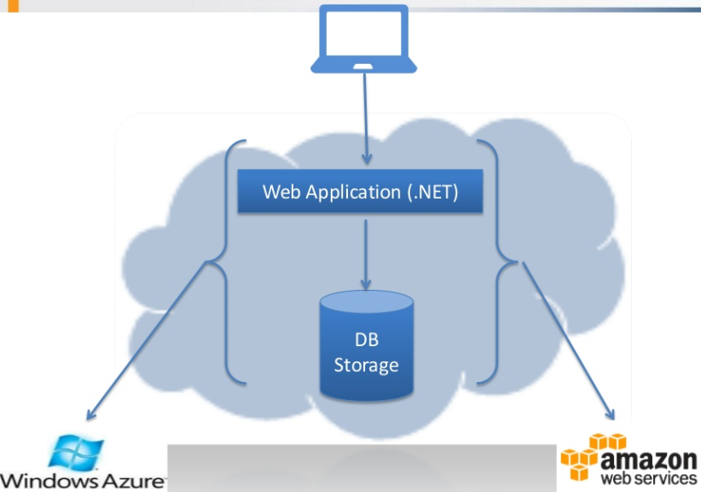

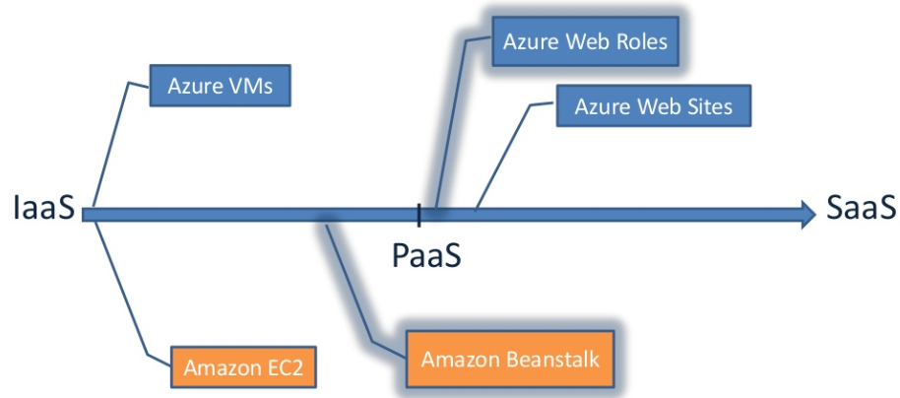

## Azure web role & SQL summary:-

* Scalability up is an issue for instance size which requires a new deployment but more instances can be added easily in the management console.
* Availability & Disaster Recovery – 99.90% for single instance and 99.95% for load balanced instances (two or more).
* Elasticity is good with Enterprise Library Auto Scaling Application Block (WASABi)
* For an application we can have only staging or production environments.
* Azure SQL DB can have maximum DB size of 150 GB with automatic scaling up till 150 GB with ‘pay for what you use’ facility but no control on instance type.
* Scaling out with SQL Azure Federations which has massive scalability with minimum down time.
* Azure SQL DB ‘Import/Export’ facility does not guaranty consistency and needs to be combined with DB Copy.
* Azure SQL DB Availability & Disaster Recovery – two standby replicas (1 synchronous & 1 asynchronous).
* Azure SQL DB – 99.9% monthly availability with internal daily backups. Backups retained for minimum 14 days. Every 5 minutes Logs are backed up.

## Amazon Elastic Beanstalk & RDS Summary:-

* For one application we can have multiple environments such as Development, QA, Staging etc.
* Keeps history of deployment versions so that we can redeploy any version to any environment.
* Scalability up is not an issue as instance size can be managed via management console and we can add more instances easily via management console/auto scaling pane.
* Availability & Disaster Recovery – 99.95% for single instance.
* Elasticity is good – need to use CloudWatch + command line procedure for advanced settings.
* Amazon RDS DB – can include SQL Server 2008 License or existing license can be used under ‘BYOL’ – Bring Your Own License program.
* Amazon RDS DB can have maximum DB size of 1000 GB.
* Amazon RDS backs up data daily and transaction logs are backed up every five minutes. Backups retained for minimum of 35 days.
* Amazon RDS – Scalability up – instance size not supported for SQL Server and Replicas for DB are also not supported for SQL Server.
* Amazon RDS - Availability & Disaster Recovery – Automatic host replacement but standby replicas not supported for SQL Server.
* Amazon RDS - DB snapshots available which restores DB to point in time (to a second). This may take several hours as it creates an instance.

Therefore, which one we should select for the migration of the current application? Verdict is clear - we need to choose Windows Azure as Amazon RDS does not provide great support to SQL Server and our current e-commerce application relies heavily on SQL Server. Also, it is difficult to migrate existing SQL Server data to Amazon RDS when compared with SQL Azure.  
Otherwise Amazon platform provides more control, massive scalability & performance and supports larger memory needs.

# Migration Strategy

Since migration strategy are not specific to the application or vendor. There are no such process, frameworks or methodology to work on a cloud adoption strategy. This is a huge challenge for senior managements and everyone, who is trying to adopt their own and fine-tune it specific to their organizational or industry goals.

Since Cloud migration is not simple as same as moving data center. Migration of data and applications to the cloud requires a huge change in thought process with complexity. Physical infrastructure that present in the corporate data center can be transformed into the cloud by leveraging one or more services and completing essential integration with the appropriate systems which enabling more efficient performance along with a significant reduction in operational costs. To migrate in to the cloud we should break them down into smaller, isolated components, so that it will work more effectively on the cloud than the physical solution in data center.

We have following Migration strategies:

* **For Migration we should opt following steps:**
* Detailed and proper assessment of existing solutions and infrastructure
* Identify the solution that can be broken down into isolated components
* To Identify most suitable implementation strategy for individual components
* Identify possible security considerations
* To Implement Federate components and services back into a complete solution
* Provision for the cloud and build auto-scaling and failover
* Establish for a disaster recovery and business continuity plan
* To Perform acceptance testing and cut over
* **We have one more Migration Strategy i.e. Syntel’s: MACH Methodology**

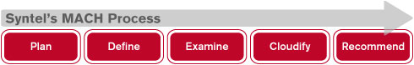

MACH methodology provides services for conducting an enterprise-wide analysis of given portfolio to help in realize critical business value from movement to cloud. They have defined that it should executed in five stages to provide cloud strategy and roadmap development.

**Plan**

* Identify the scope of the work, along with applications to be migrated to cloud
* To Create the plan for the overall and detailed assessment exercise
* To Confirm deliverables

**Define**

* To identify the objective and drive for moving to cloud
* List out key problem areas in the current as-is solution (cloud/non-cloud)
* Discuss and take a confirm with stakeholders and drivers for the exercise
* Identify and list down key success criteria (KSC)

**Examine**

* Review as-is architecture of each application that needs to be moved to cloud
* Review the touch points for the application with other systems
* To review current and future user requirements and understand non functional requirements from each application
* Review entire deployment strategy
* Document all the gaps Identified

**Cloudify**

* Feasibility analysis on moving applications to cloud
* Identify architectural changes that required if any to bridge the gaps identified
* Identify management tools that can manage the cloud application/s
* Identify administrative controls that can be offered to technology stakeholders
* Do a POC and benchmarking (This can be optional)
* To Prepare road map for upgrading applications to move on cloud

**Recommend**

* Present all the changes require in the architecture along with business and technology benefits
* To Present the roadmap for moving applications to cloud
* To Provide effort and cost estimates for moving to cloud (This can be optional)
* **Another strategy is 4 Point Strategy**

**1. Getting things off the ground – Known as The Pre-work:**

This is the fundamental step of the entire framework and creates the foundation. High-level steps around this would be:

1. To Set up the cloud task force
2. To identify and align IT processes with cloud focus
3. To Create a timeline-based chart on cloud adoption
4. To Establish the principles of cloud adoption & get business buy-in

**2. Alignment with business objectives & functions:**

In this step, the crucial stride to categorize & prioritize the IT processes/workloads in term of cloud readiness. Few of the steps that should be followed to arrive at a logic alignment with cloud readiness are

1. To Conduct a business information assessment
2. To Conduct cost model assessment (Blaze Clan has built an integrated tool to conduct this practically).
3. To Consider changes that affecting organization processes on cloud adoption
4. To Collect requirements and checklists for each business application/IT process/workload
5. To Evaluate cloud readiness (both private and public) – it will determined based on multiple parameters like Compliance, business criticality, long-term objective etc.
6. List out all the priorities & steps of cloud migration

**3.  Choose the right vendor and the right service provider:**

This is the major step in cloud adoption, the criticality based in making not just the right but also the long time choice.

1. To Make the choice of the service provider not only based on pricing but their business needs
2. Their choice should be based on both functional and technology support provided by the service provider.
3. Check for existing case studies for similar industries or functions where IT functions have seen some results for compression.
4. Choose the right vendor to implement and support for the adoption, preferably one referred by the service provider or one who has implemented the service for customers.

**4. Keep Monitoring, Keep Optimizing:**

After adoption (Post Adoption), need for continuous monitoring to ensure the results that are set out to achieve in the first place.

1. To Monitor the ROIs along with the performance that achieved over short periods. Many cloud services have their tools, which would help us to do medium to high-level performance monitoring.
2. There is no stop for optimizing the processes. Ensure that your team or your vendor does it only for you with newer methods and best practices.
3. To contribute back by giving feedback to the vendor and even the service provider about the observations and needs.

Cloud adoption is one of the difficult stages for any enterprise to undertake. With the right support and the right partner, it should be like an exercise for taken things in the right direction with right strategy.

Key migration issues  
  
E-commerce enterprise should concentrate on the core competencies. Since E-commerce is a new kind of business mode through virtue of computer network, an E-commerce enterprise emphasizes the operation and management. Cloud computing will threaten the traditional IT enterprises including E-commerce firms.

For example, customers are able to utilize the software by the “pay-as-service” charging mode rather than buy it from the traditional E-commerce website. As a result the market share of the E-commerce enterprises, which focus on the online software sales will decrease. Development of cloud computing will result in the information technology to become the inexpensive in term of public resource, which is accessible to all the people. As a result, information technology will not be the core competency of an E-commerce enterprise industry. Therefore, an E-commerce enterprise should emphasize the business operation and management more.

Apart from it E-commerce enterprise should focus on the innovation of business mode and operation mode since they are the critical factors for an enterprise’s success.

For example, Alibaba is building its E-commerce cloud center since 2009. Their plans to integrate the cloud center with the existed data center and establish the business cloud, which can compete with the existing cloud services providers like Google. By virtue of the business cloud offered by Alibaba, users would not have to concern about the complex IT infrastructure and only need to rent the cloud services based on the demand to achieve the goals.

An E-commerce enterprise industry should cooperate with cloud service provider, to improve the operation capability. Since the cloud computing development is unaffordable for most of the E-commerce enterprises, it requires the close cooperation with partners. The cooperation with cloud service provider enables the E-commerce enterprise especially the medium and small enterprises to find new heights.

There are other issues as given below:

**A. Security -** Security of data in public Clouds is a big concern. Although CSPs always say that the information of clients are stored securely on the Cloud still e-commerce companies and Cloud end-users worry about the security of their data because their sensitive data are in the hands of Cloud service providers.

**B. Privacy -** Cloud Computing is based on the existing distribute network. Computers are the part of Cloud as soon as they connect to the Internet. Primarily E-commerce activities require customer’s personal information, like name, address, bank details, etc. Attackers can attack the individual privacy by using links between data.

**C. Cost -** Cloud Computing is also attractive as it can save them millions of dollars to build their own servers and storage environment. The cost of Cloud service matters a lot to e-commerce companies and other consumers. Prices of Cloud service are relatively very low. Organizations need to estimate Cloud Computing costs and compare these costs with conventional IT solutions. Cost and benefit analysis is important for managers to evaluate the benefits.

**D. Quality -** It is a crucial factor for the success of Cloud providers as it may destroy a provider‘s reputation. Computing services need to be highly reliable, scalable, compensability and dynamic discovery. Cloud service providers like Amazon, Google, IBM, Microsoft and Salesforce have established their own data centers for hosting Cloud applications in various locations around the world to provide redundancy and ensure reliability in case of site failures.

SLAs give assurance to end-users about the services they have paid for by providing a facility to agree upon.

**E. Migration -** The four factors that discussed above (security, privacy, cost and quality) are the issues, which all e-commerce companies should consider about before moving to Cloud. Companies should calculate the effort required to migrate because they have their own infrastructure. This required effort is due to the discrepancies between the environments provided by a Cloud platform and a traditional platform i.e. differences in the version of various infrastructures, libraries, and programming models, even the semantics of data access.

**F. Selecting the correct Cloud platforms and services (IaaS or PaaS) -** This affects the effort and cost required for the rest of migration activities. Less effort is required for modification if the selected Cloud platform is highly similar to the application‘s environment in the local server.

**G. Compatibility issues -** This factor is affected by the similarity of Cloud platforms and local servers as well. Compatibility issue can be eliminated when the similarity is high.

**H. Library dependency -** If an application relies on a library for functioning in local server, it requires a similar library in the Cloud platform also if there is such a library for Cloud existing, less effort would be required to rewrite that library.

**I. Connection issues** - In the Cloud migration if some components of the system are migrated to Cloud and remaining systems are kept in house, the connection between two parts of the system (one in house and the other one in Cloud) may face issues such as latency, security, etc.

# Migration risks and mitigation

Every time, there is a re-engineering of a well-oiled system to a new system or migrating application from an old hardware to a new hardware or change in the process, there is always a risk related to the performance, meeting user expectation , security related to identity management, who can access what , validation , verification and so on… but the risk becomes easier to mitigate , if there is a plan to understand what are the risk associated with it and if these can be identified earlier in the process then it becomes easier to mitigate the risk and devise a fall back plan. More or less, every migration has the above risk irrespective of where the application is migrated only the periphery of the risk becomes bigger and broader.

So the plan is to keep the periphery of the risk smaller to make it manageable. While migrating to the cloud having similar set up that we have in a non-cloud environment like development, QA, UAT, PRE-PROD and Prod will help. So the application gets a longer time to go through the cloud environment. A phase wise deployment will always help to build the confidence level and less integration issues. While choosing for phase wise implementation, choosing the most non-critical application will be of less risk in the beginning and over the period of time, the expertise and confidence gets build to deploy more complex application. Choosing a cloud provider, catering to companies that are similar in size and structure to our business will help.

Once a non-critical application is moved to cloud, a through functional test by the QA and UAT will always boost the confidence level of the people. This is to have set of test data, whose output is known, can be used to know the functionality of the application. As we know, data doubles every 18 months, the data can be extrapolated by at least 5 times, to understand the behavior of the system as well as how cloud scales to provide the desired performance. Coming to performance from the point of access can be simulated by applications which can refer to the information on the cloud by users to the tune of 500%. This will help to understand the access mechanism and how fast or slow is it. Other testing related to performance can be carried out based on the mixed load at the similar time, to understand how the system is behaving when there is writing to as well as read from the system by the application.

Having proper encryption logic in place for data security and an access mechanism about “who can access what” will help and this can be deduced from strong governance being in place.

A strong audit trail to the lowest detail level stored for at least 7 years can be put in place to understand what has happen to the system over a period of time, who has changed what.

While putting into the cloud, we need to understand what type of security; encryption, firewall etc. are provided by the cloud provider and whether that suffices our need for security.

So if identity management, proper security, performance & scalability, a good audit trail in place, then the periphery of the risk can be reduced and a well-designed mitigation plan can be put in place like falling back quickly to the old system etc….

# Total cost ownership analysis

Every 18 months the data doubles - Moore's law

With this concept in mind, when data doubles every 18 months, there must be technology in place to handle this volume of data from the point of consumption as well as making it available for taking the right decision.

Here in our company the following Software are used which are Windows Server 2008, IIS7.5, ASP.NET4.0 and MSMQ with SQL server 2008

This decision was taken based on the traffic volume as well as the response time needed at the time and the future requirement in next 3 years.

With 5 years gone by, the overall approach to managing the data volume as well as response time to the user queries have changed completely.

With volume growth and better response time need, there is a need to work at various layer of the architecture with minimum cost and maximum productivity.

Here we will be covering in upgrading the Server stack, the network stack as well as the database stack.

There are two choices available at this point; either we host it ourselves by getting new HW/SW or rent the related hardware and software as PaaS from Public cloud.

So this decision will be based on the ROI

Let's look at hosting it ourselves (Typical usage of the system is around 30 to 40% per day and at certain times it peaks to 90% - Spike), so most of the time the system is not fully utilized.

|  |  |  |  |  |  |  |  |  |  |  |  |  |
| --- | --- | --- | --- | --- | --- | --- | --- | --- | --- | --- | --- | --- |
| **Hosted within the company** | |  | |  | |  | |  | |  | |  |
| **Sl No** | **SW** | | **One time cost** | | **Recurring License Cost** | | **Maintenance Cost (Personnel)** | | **End of 1st year** | | **End of 2nd year** | |
| 1 | Windows 2008 Server R2 | | 70000 | | 24000 | | 1200000 | | 1270000 | | 1224000 | |
| 2 | MS Sql Server 2008 EE | | 240000 | | 24000 | | 1600000 | | 1840000 | | 1624000 | |
| 3 | Network - High speed | | 120000 | |  | | 1400000 | | 1520000 | | 1400000 | |
| Total cost - Price in Indian rupees |  | |  | |  | |  | | 4630000 | | 4248000 | |
| HW Cost |  | |  | |  | |  | | 70000 | |  | |
| Total HW + SW Cost |  | |  | |  | |  | | 4700000 | | 4248000 | |
|  |  | |  | |  | |  | |  | |  | |
| **Hosted on Cloud – cost in INR** |  | |  | |  | |  | |  | |  | |
| **Instance** | **Virtual Cores** | | **RAM** | | **Price per hour** | | **Price per year** | |  | |  | |
| Large (A3) | 4 | | 7 GB | | Rs.20.00 | |  | |  | |  | |
| Per Month |  | |  | | 16000 | | 192000 | |  | |  | |
| Database | DB Size | | Price per month | |  | |  | |  | |  | |
| SQL Server 2012 | 500 GB | | 33000 | |  | | 396000 | |  | |  | |
| Storage cost | Geographically redundant | |  | |  | |  | |  | |  | |
| 1 TB / Month | 6000 | |  | |  | | 72000 | |  | |  | |
| Total for 1st year |  | |  | |  | | 660000 | |  | |  | |
| **The price will vary on actual consumption –Pay as you go** | | | | | | | | |  | |  | |

**Based on the cost comparison, it makes sense to host it on the cloud……**

# Future benefits

**Data insights**

Cloud computing is still very much in the growing phase and is touted as the way of computing infrastructure of the future - expert and studies highlight that due to the ease of maintenance and availability this will be the preferred for application hosting , service based computing infrastructure and platforms. Coupled with the adoption of big data this will be the most sort after area for adoption. Big data with the cloud solution will help companies to tackle complex problems and scale-up and scale-down as per the need without investing a fortune for the infrastructure. In an ecommerce world, it will be a game changer to have the ability to data mine user preferences and trends and predict the need well in advance or introduce features and products to enhance the user experience. Currently well-known ecommerce players have already adopted such data solutions and have been successful. E-commerce application on AWD from Amazon is an example to show that even smaller player gets to enter the market and have a level playing ground when it comes to computation backbones

**Predict Monitoring Application Model**

The cloud computing will open up more opportunities to migrate from a proactive application monitoring model to a predictive model. Predict model is used in high available critical system, which is highly effective but cost intensive. By migrating the predictive model to the clouds, business will be able to mitigate risk on the systems and come up with more precise forecast and optimize resources. This will be game changer for any e-commerce player – this would give them the capability to scour through large volumes to data and comes up with a usage set of data which gives the current state of business and options how these channels can be optimized to yield the best outcomes. This will aid the e-commerce manager to informed decisions almost in real time which otherwise would take a lot of time and consume resources which translates to cost.

**Technology to Ensure Uptime**

Ecommerce business needs to be guaranteed uptimes to convert all opportunity into revenue - downtimes can have very negative impact on how business is conducted and how users’ perceptions are set. Apart from having guaranteed uptime, it is also important that the turnaround time or response times are also minimized. Cloud computing helps in mitigating both these risks as the system grows - it will more cost efficient to add more hardware on demand to address the high availability requirements as well to have failover mechanisms built into the ecosystem thus making the concerns close to obsolete.

**Going Mobile**

Adding mobility into the business model will be added advantage to ecommerce model. Mobile applications are a rapidly developing segment of the global mobile market.[2][8] They consist of software that runs on a mobile device and perform certain tasks for the user of the mobile phone. As reported by World Mobile Applications Market, about 7 billion (free and paid) application downloads were made globally in 2009 alone from both native and third-party application stores, generating revenues of $3.9 billion in the same year. The global mobile application market is expected to be worth $24.4 billion in 2015, growing at a CAGR of 64% from 2009 to 2015. Apple is a typical example for the explosion of mobile applications. Apple with a whopping more than 4 billion downloads to date commanded more than 90% of the application market share in 2009. The success of Apple’s App Store has not only established the scalability of mobile applications, but has also shown that the best of these offer the potential to generate enormous revenues (*en.wikipedia.org/wiki/Mobile_cloud_computing*).

**Cost Advantage**

Every business needs are different but it very important to understand the cost saving that cloud computing can bring to an organization in most of all cases. The economies of scale and utility based pricing model are the biggest saving that can be achieved from moving to cloud computing. An example of the cost saving comparison can be found below, which was extracted from a case study available on O’Reilly Media

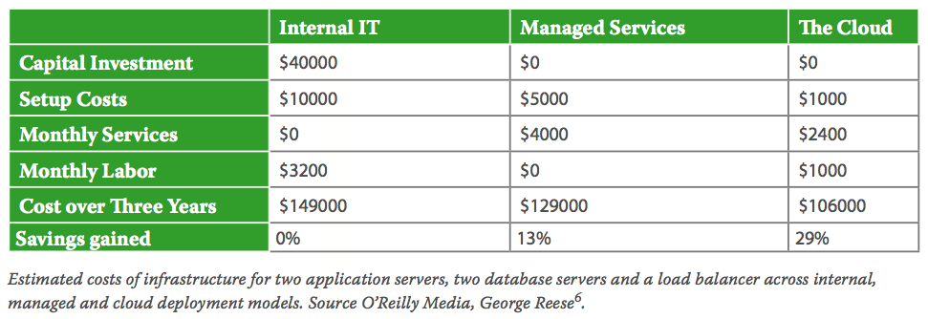

The other advantage is utility based pricing – or ‘pay as you use’ model. This is very helpful in the business ecosystem of ecommerce players – where they can pay of the initial needs and as required over time to increase or decrease on how much resources are needed. An example would be the holiday shopping on a ecommerce site , this is the time when the resource utilization is at the peak and when there is a need to scaling which need not be required after this peak season – Clouding computing gives these player the flexibility to launch more servers and guaranteed uptimes and fast responses, though this comes with technical challenges and solution to be developing cost which is still advantages compared to self-hosting/datacenter model. The companies can shift from a Capital investment model (CAPEX) to an Operational expenditure model (OPEX)

**Security and compliance**

Any business that needs computing infrastructure need to adhere to security and compliance requirements. The long term advantage a cloud infrastructure give is providing experts solutions in standardized way, which otherwise is an effort that needs to be business needs to develop on its own. Requirements like vendor compliance like HIPPA, SAS70, SSAE16, PCI DSS are already available with the infrastructure and it will also be up to date with other complained that may be mandated in future. Most Cloud provides are SAS 70 Type II audits a global auditing standard designed to evaluate and issue an opinion on a service organization’s controls. As an ecommerce player it will be always helpful to have the in-built solutions available which help the business to concentrate more on the core business and not worry of compliances which may be a mandatory requirement as they grow

# Conclusion

Ecommerce sites face severe restriction when it comes to security, Capital, technical resources. Though the first one can be purchase off-the-shelf solutions which are custom made of ecommerce need, but it be an added effort to implement and maintain it and not to mention the gap in fitment in most cases and every business requirements are every organization specific. Capital requirement for an ecommerce business infrastructure is rather high compared to other model and requires a dedicated team of technical resources - This challenges can be mitigated by adopting a hybrid/complete cloud solution where these are handled by the provide and the business can concentrate on the core business. Optimized data mining tools, data storage solutions are already available at utility based pricing.

An E-commerce enterprise should cooperate with cloud service provider so as to improve the operation capability. Since the cloud computing development is unaffordable for most of E-commerce enterprises, it requires the close cooperation with partners. The cooperation with cloud service provider enables the E-commerce enterprise especially the medium and small enterprises to find a new way.

Cloud computing is definitely revolutionizing the IT domain, providing unprecedented advantage to organization especially the smaller ecommerce players and giving them a level playing ground. Adoption of any new technology comes with its own risk which needs to be balanced effectively. This technology changed the way traditional websites are being built and operated and it’s a paradigm shift. Business decision makers need to be well informed of the issues that are directly impacting them like cost benefits, security and performance and need to do the due diligence from their side too which is as important as the what IT decision makers do. Independent advice should be obtained from experts on how to align the business requirement with the product offering and implementing it. Case studies shows that there are important socio-technical issues that need to be considered before organizations could migrate their IT systems to the cloud

There will also be change in the expected skill on C-level executive where data science of the most sought after skills and the way they approach opportunities on a traditionally. Mastering the opportunity on cloud without giving up on other aspects will be the competitive advantage for business in future.

It is also worth mentioning that the current ecommerce adoption to cloud is still in early stages of exploration and discovery. Though some of the offering from the providers like security, storage and yet to be completely resolved in practice, but lots of research and developments are happening in this domain and the whole eco system is getting more sophisticated and secure with every passing day. For a domain like eco-commerce cloud computing gives all the right reasons to adopt and will be widespread, and will be a game changer and will revolutionize the offerings.

# References

1. <http://www.cisco.com/en/US/services/ps2961/ps10364/ps10370/ps11104/Migration_of_Enterprise_Apps_to_Cloud_White_Paper.pdf>
2. <http://www.slideshare.net/tekcraft/azure-vsamazon>
3. <http://blog.blazeclan.com/4-important-steps-cloud-migration/>
4. <http://www.syntelinc.com/mach/>
5. <http://www.compunnel.com/it-services/cloud-services/cloud-migration-strategy.html>
6. OReilly Media
7. Wikipedia.com
8. <http://arxiv.org/ftp/arxiv/papers/1002/1002.3492.pdf>
9. <http://www.boozallen.com/media/file/Economics-of-Cloud-Computing.pdf>

# Disclaimer

This project report may contain confidential data of certain organizations. It may only be used for academic purpose in teaching business administration at IIM Kozhikode. Confidentiality has to be maintained about the content. Publications and duplications of the content in any form are forbidden. For data privacy reasons certain names have been masked.